**INTRODUCTION**

The functionality of skin plays a vital role in the human body since it is the largest organ which covers the muscles, bones, and other parts of the body. Once the functionality of skin goes wrong it affects the other parts of the body. Skin is the most sensitive part, therefore when it is explored into sunlight and other environmental pollution tends to occur skin cancer. Skin cancer appears to be of two kinds Benign and Melanoma form. Benign it’s just the moles on the skin which does not penetrate inside, whereas Melanoma causes sores on the skin which leads to bleeding, and it is named after cells Melanocytes which is more hazardous. In United States, more than 700,000 skin lesions are diagnosed annually under the estimation of American Cancer Society. According to statistics given by the Apollo and other hospitals it suggests that Melanoma affects the ages ranging from 41-60+. There are technologies that are used to detect skin cancer at the early stages. Skin Cancer detected in advance can save people’s lives and it eliminates the multiplication of cancer cells across the parts of the body. Although it affects the people within age limits but high probably is for the bright skin people. It will be hard for even the experienced dermatologist to detect the skin cancer or to predict the stages. Therefore, much hardware & software devices and applications evolved. In order to detect Non- Melanoma Skin Cancer (NMSC) there are many hardware devices which includes, biopsy, molecular markers, ultra-sonography, Doppler, optical coherence tomography, Dermoscopy and spectroscopy. Dermoscopy is one such hardware device that helps in examining the surface of the skin using skin surface microscopy for the detection of skin cancer; it is a non-invasive examination technique that lends the support to distinguish between Melanoma and Non-Melanoma. It is the most expensive device that cannot be affordable for the poor countries and developing countries like Africa. Moreover, later researchers came up with many software applications, which eliminated the hardware cost and influence the ease of usage. The software does not require any expertise to handle them but developed with the intention of prior information about the cancer. Image Processing is one of the traditional approaches which deals with analyzing and processing of an image. Image processing has proposed many methodologies which helps in the early detection of skin cancer. Proposed methodologies have influenced in the early detection which prevents the cancer from spreading across the skin. The methodology in an image processing approach involves the use of Noise removal, Edge detection, Image enhancement, Segmentation algorithms, Feature selection, Feature extraction, calculating Area, Perimeter, Eccentricity, Neural network approach using Back propagation algorithms. In this work, a model is proposed with an aim of detecting the skin cancer along with type of cancer information to the people. Model detects the skin cancer on the color skin image and uses pre-processing methods such as Image acquisition, Noise removal and plotting Histogram. Pre-processing methods helps to solve the illumination, contrast, and noise problems. After the removal of noise various techniques such as Edge detection, Image enhancement, Segmentation. Feature extraction is used to extract the affected portion of skin, then the Area, Perimeter and Eccentricity is calculated. Calculated values are fed into the Neural networks, using Back propagation algorithm the stage and type of the skin cancer is predicted. The main aim of the proposed system is to eliminate the risk caused by many countries with respect to the skin cancer. Many hardware devices were developed but those devices were not affordable. Patients are not only provided with the information of type of cancer, but appropriate stage of the skin cancer is predicted which helps to easily cure the cancer when stage is obtained.

**LITERATURE SURVEY**

**EXISITNG SYSTEM**

Many studies have applied deep learning algorithms in classification of skin diseases. Daily soft drink consumption significantly increases the risk of moderate-to-severe acne in adolescents, especially when the sugar intake from any type of soft drink exceeds 100 g per day. Rosacea is one of the common chronic facial disorder that affects the patients health. The adjusted Chinese-version RosQol was easy to complete, well received by patients, and demonstrated acceptable validity and reliability. The results indicate that leptin plays a critical role in the development of autoimmune disorders and demonstrate that the transgenic leptin pigs will be act as a valuable model of SLE. Certain results argue strongly to include skin disease prevention and treatment in future global health strategies as a matter of urgency. The results in ‘‘Symptoms of systemic lupus erythematosus are diagnosed in leptin transgenic pigs,’’ indicate that leptin plays a critical role in the development of autoimmune disorders and demonstrate that our transgenic leptin pigs can act as a valuable model of SLE.

**PROPOSED SYSTEM**

A neural network is a type of machine learning algorithm allows the computer to learn by incorporating new data. CNNs is very useful in image recognition in order to analyse visual imagery and are frequently used in classifying the images. It takes the given three classes of skin disease images as input and it gives the output of a probability that the input belongs to a particular class. CNN is now the go-to model on every image related problem. The main advantage of CNN compared to its predecessors is that it automatically detects the important features without any human superintendence.

**Methodology**

Proposed system is a web application that acts as a preliminary step for the diagnosis of a disease where a person uploads the image of the affected area of the skin and then gets to know the type of the disease and few suggestions are given regarding the disease using this application.The proposed framework involves a deep learning-based method to detect skin diseases. This system will utilize computational techniques to analyse, process, and relegate the image data predicated on various features of the images.The Architecture of skin disease detection and classification system is shown in the following figure 1.

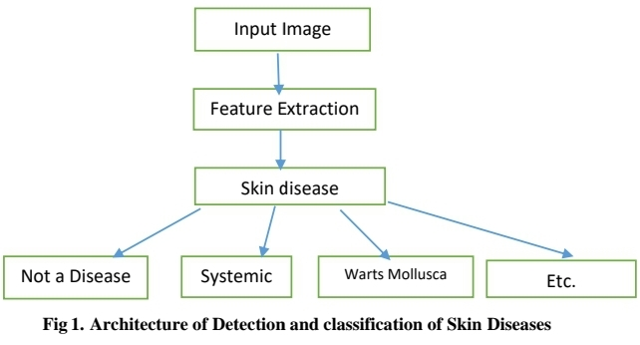

**IMPLEMENTATION**

**Deep Neural Network Architectures**

**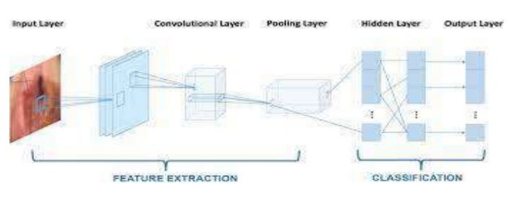CNN architecture**

Fig 2.CNNArchitecture

The Convolutional neural network shown in figure 2 consists of an input layer, hidden layers and an output layer. In any feed-forward neural network, middle layers are called hidden because their inputs and outputs are masked by the activation function and final convolution. In a convolutional neural network, the hidden layers include layers that perform convolutions. This product is usually the Frobenius inner product, and its activation function is commonly ReLU. As the convolution kernel slides along the input matrix for the layer, the convolution operation generates a feature map, which in turn contributes to the input of the next layer. This is followed by other layers such as pooling layers, fully connected layers, and normalization layers. Convolutional layers convolve the input and pass its result to the next layer. Pooling layers reduce the dimensions of data by combining the outputs of neuron clusters at one layer into a single neuron in the next layer. Fully connected layers connect every neuron in one layer to every neuron in another layer [8].

**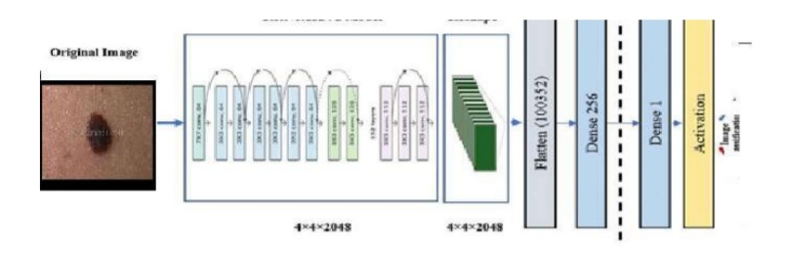ResNet152V2**

Fig.3 ResNet152V2 Architecture

The architecture of ResNet152V2 is shown in figure 3. It is used as a feature extraction model which is trained on imageNet dataset. The model has initial weights because it is a pre-trained model, which can help to gain acceptable accuracy faster than a traditional CNN. The model architecture consists of the ResNet152V2 model followed by a reshape layer, a flatten layer, a dense layer with 128 neurons,a dropout layer, and finally a dense layer with Softmax activation function to classify the image into its corresponding class. Resnet introduces a structure called residual learning unit to alleviate the degradation of deep neural networks[9]. This unit’s structure is a feedforward network with a shortcut connection which adds new inputs into the network and generates new outputs. The mainmerit of this unit isthat it produces better classification accuracy without increasing the complexity of the model.

**AlexNet**

AlexNet is the name of a convolutional neural network which has had a large impact on the field of machine learning, specifically in the application of deep learning to machine vision. It is attached with ReLU activations after every convolutional and fully-connected layer.

As shown in figure 4, the Alexnet has eight layers with learnable parameters. The model consists of five layers with a combination of max pooling followed by 3 fullyconnected layers and used Relu activation in each of these layers except the output

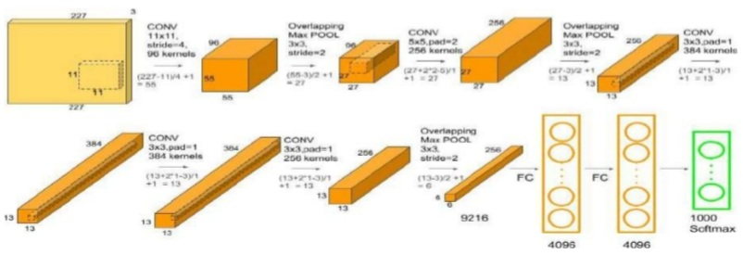Fig. 4 Alexnet Architecture

The input to the Model is RGB images. It accelerates the speed by 6 times at the same accuracy. It used two Dropoutlayers. The activation function used in the output layer is Softmax. The total number of parametersin this architecture is 62.3 million [10].

**Inception-v3**

As shown in the figure 5, Inception v3 is a pretrained model which was originally trained on ImageNet dataset which has over a million images from 1,000 classes on some verypowerful machines. Being able to retrain the final layer meansthat you can maintain the knowledgethat the model had learned during its original training and apply it to your smaller dataset, resultingin highly accurate classifications without the need for extensive training and computational power [11].

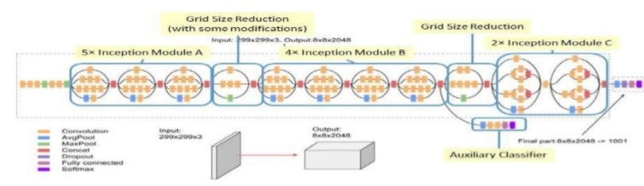Fig.5. Inception-v3

According to the facts, training and testing of DL-CNN involves in allowing every source image via a succession of convolution layers by a kernel or filter, rectified linear unit (ReLU), max pooling, fully connected layer and utilize SoftMax layer with classification layer to categorize the objects with probabilistic values ranging from [0,1]. Figure 1 discloses the architecture of DL-CNN that is utilized in proposed methodology for skin cancer detection and classification system for enhanced feature representation of dermoscopic image over conventional detection systems.

****Fig. 1: CNN architecture for proposed skin cancer detection and multi-class classification.

Convolution layer as depicted in Figure 2 is the primary layer to extract the features from a source image and maintains the relationship between pixels by learning the features of image by employing tiny blocks of source data. It’s a mathematical function which considers two inputs like source image I(x,y,d) where x and y denotes the spatial coordinates i.e., number of rows and columns. d is denoted as dimension of an image (here d=3, since the source image is RGB) and a filter or kernel with similar size of input image and can be denoted as F(k\_x,k\_y,d).

Fig. 2 Representation of convolution layer process.

The output obtained from convolution process of input image and filter has a size of C((x-k\_x+1),( y-k\_y+1),1), which is referred as feature map. An example of convolution procedure is demonstrated in Figure 3. Let us assume an input image with a size of 5×5 and the filter having the size of 3×3. The feature map of input image is obtained by multiplying the input image values with the filter values as given in Figure 3.

Fig. 3 Example of convolution layer process (a) an image with size 5×5 is convolving with 3×3 kernel (b) Convolved feature map

**ReLU layer**

Networks those utilizes the rectifier operation for the hidden layers are cited as rectified linear unit (ReLU). This ReLU function G(∙) is a simple computation that returns the value given as input directly if the value of input is greater than zero else returns zero. This can be represented as mathematically using the function max(∙) over the set of 0 and the input x as follows:

G(x)=max⁡{0,x}

**Max pooing layer**

This layer mitigates the number of parameters when there are larger size images. This can be called as subsampling or down sampling that mitigates the dimensionality of every feature map by preserving the important information. Max pooling considers the maximum element form the rectified feature map.

**REQUIREMENT SPECIFICATION**

**Functional Requirements**

* Graphical User interface with the User.

**Software Requirements**

For developing the application the following are the Software Requirements:

1. Python
2. Django
3. Mysql
4. Wampserver

**Operating Systems supported**

1. Windows 7
2. Windows XP
3. Windows 8

**Technologies and Languages used to Develop**

1. Python

**Debugger and Emulator**

* Any Browser (Particularly Chrome)

**Hardware Requirements**

For developing the application the following are the Hardware Requirements:

* Processor: Pentium IV or higher
* RAM: 256 MB
* Space on Hard Disk: minimum 512MB

**SYSTEM STUDY**

**FEASIBILITY STUDY**

The feasibility of the project is analyzed in this phase and business proposal is put forth with a very general plan for the project and some cost estimates. During system analysis the feasibility study of the proposed system is to be carried out. This is to ensure that the proposed system is not a burden to the company. For feasibility analysis, some understanding of the major requirements for the system is essential.

Three key considerations involved in the feasibility analysis are

* ECONOMICAL FEASIBILITY
* TECHNICAL FEASIBILITY
* SOCIAL FEASIBILITY

**ECONOMICAL FEASIBILITY**

This study is carried out to check the economic impact that the system will have on the organization. The amount of fund that the company can pour into the research and development of the system is limited. The expenditures must be justified. Thus the developed system as well within the budget and this was achieved because most of the technologies used are freely available. Only the customized products had to be purchased.

**TECHNICAL FEASIBILITY**

This study is carried out to check the technical feasibility, that is, the technical requirements of the system. Any system developed must not have a high demand on the available technical resources. This will lead to high demands on the available technical resources. This will lead to high demands being placed on the client. The developed system must have a modest requirement, as only minimal or null changes are required for implementing this system.

**SOCIAL FEASIBILITY**

The aspect of study is to check the level of acceptance of the system by the user. This includes the process of training the user to use the system efficiently. The user must not feel threatened by the system, instead must accept it as a necessity. The level of acceptance by the users solely depends on the methods that are employed to educate the user about the system and to make him familiar with it. His level of confidence must be raised so that he is also able to make some constructive criticism, which is welcomed, as he is the final user of the system.

**SYSTEM DESIGN**

**UML DIAGRAMS**

UML stands for Unified Modeling Language. UML is a standardized general-purpose modeling language in the field of object-oriented software engineering. The standard is managed, and was created by, the Object Management Group.

The goal is for UML to become a common language for creating models of object oriented computer software. In its current form UML is comprised of two major components: a Meta-model and a notation. In the future, some form of method or process may also be added to; or associated with, UML.

The Unified Modeling Language is a standard language for specifying, Visualization, Constructing and documenting the artifacts of software system, as well as for business modeling and other non-software systems.

The UML represents a collection of best engineering practices that have proven successful in the modeling of large and complex systems.

The UML is a very important part of developing objects oriented software and the software development process. The UML uses mostly graphical notations to express the design of software projects.

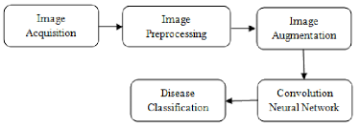

**GOALS:**

The Primary goals in the design of the UML are as follows:

1. Provide users a ready-to-use, expressive visual modeling Language so that they can develop and exchange meaningful models.
2. Provide extendibility and specialization mechanisms to extend the core concepts.
3. Be independent of particular programming languages and development process.
4. Provide a formal basis for understanding the modeling language.
5. Encourage the growth of OO tools market.
6. Support higher level development concepts such as collaborations, frameworks, patterns and components.
7. Integrate best practices.

**USE CASE DIAGRAM:**

A use case diagram in the Unified Modeling Language (UML) is a type of behavioral diagram defined by and created from a Use-case analysis. Its purpose is to present a graphical overview of the functionality provided by a system in terms of actors, their goals (represented as use cases), and any dependencies between those use cases. The main purpose of a use case diagram is to show what system functions are performed for which actor. Roles of the actors in the system can be depicted.

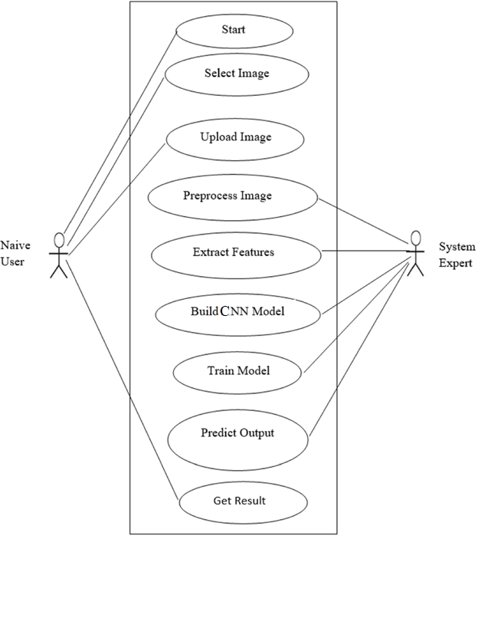

**CLASS DIAGRAM:**

In software engineering, a class diagram in the Unified Modeling Language (UML) is a type of static structure diagram that describes the structure of a system by showing the system's classes, their attributes, operations (or methods), and the relationships among the classes. It explains which class contains information.

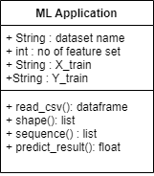

**SEQUENCE DIAGRAM:**

A sequence diagram in Unified Modeling Language (UML) is a kind of interaction diagram that shows how processes operate with one another and in what order. It is a construct of a Message Sequence Chart. Sequence diagrams are sometimes called event diagrams, event scenarios, and timing diagrams.

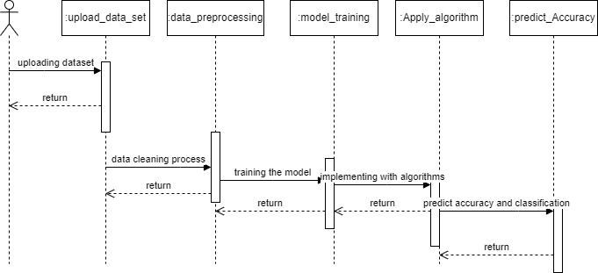

**ACTIVITY DIAGRAM:**

Activity diagrams are graphical representations of workflows of stepwise activities and actions with support for choice, iteration and concurrency. In the Unified Modeling Language, activity diagrams can be used to describe the business and operational step-by-step workflows of components in a system. An activity diagram shows the overall flow of control.



**SOFTWARE ENVIRONMENT**

What is Python :-

Below are some facts about Python. Python is currently the most widely used multi-purpose, high-level programming language. Python allows programming in Object-Oriented and Procedural paradigms. Python programs generally are smaller than other programming languages like Java Programmers have to type relatively less and indentation requirement of the language, makes them readable all the time. Python language is being used by almost all tech-giant companies like – Google, Amazon, Facebook, Instagram, Dropbox, Uber… etc. The biggest strength of Python is huge collection of standard library which can be used for the following –

* + [Machine Learning](https://www.geeksforgeeks.org/machine-learning/)
  + GUI Applications (like Kivy, Tkinter, PyQt etc. )
  + Web frameworks like Django (used by YouTube, Instagram, Dropbox)
  + Image processing (like Opencv, Pillow)
  + Web scraping (like Scrapy, BeautifulSoup, Selenium)
  + Test frameworks
  + Multimedia

Advantages of Python :-

Let’s see how Python dominates over other languages.

1. Extensive Libraries

Python downloads with an extensive library and it contain code for various purposes like regular expressions, documentation-generation, unit-testing, web browsers, threading, databases, CGI, email, image manipulation, and more. So, we don’t have to write the complete code for that manually.

#### 2. Extensible

As we have seen earlier, Python can be**extended to other languages**. You can write some of your code in languages like C++ or C. This comes in handy, especially in projects.

#### 3. Embeddable

Complimentary to extensibility, Python is embeddable as well. You can put your Python code in your source code of a different language, like C++. This lets us add **scripting capabilities**to our code in the other language.

#### 4. Improved Productivity

The language’s simplicity and extensive libraries render programmers**more productive** than languages like Java and C++ do. Also, the fact that you need to write less and get more things done.

#### 5. IOT Opportunities

Since Python forms the basis of new platforms like Raspberry Pi, it finds the future bright for the Internet Of Things. This is a way to connect the language with the real world.

#### 6. Simple and Easy

When working with Java, you may have to create a class to print **‘Hello World’**. But in Python, just a print statement will do. It is also quite **easy to learn, understand,** and**code.** This is why when people pick up Python, they have a hard time adjusting to other more verbose languages like Java.

#### 7. Readable

Because it is not such a verbose language, reading Python is much like reading English. This is the reason why it is so easy to learn, understand, and code. It also does not need curly braces to define blocks, and **indentation is mandatory.** This further aids the readability of the code.

#### 8. Object-Oriented

This language supports both the **procedural and object-oriented**programming paradigms. While functions help us with code reusability, classes and objects let us model the real world. A class allows the **encapsulation of data** and functions into one.

#### 9. Free and Open-Source

Like we said earlier, Python is **freely available.** But not only can you[**download Python**](https://data-flair.training/blogs/install-python-windows/) for free, but you can also download its source code, make changes to it, and even distribute it. It downloads with an extensive collection of libraries to help you with your tasks.

#### 10. Portable

When you code your project in a language like C++, you may need to make some changes to it if you want to run it on another platform. But it isn’t the same with Python. Here, you need to**code only once**, and you can run it anywhere. This is called **Write Once Run Anywhere (WORA)**. However, you need to be careful enough not to include any system-dependent features.

#### 11. Interpreted

Lastly, we will say that it is an interpreted language. Since statements are executed one by one, **debugging is easier** than in compiled languages.

Any doubts till now in the advantages of Python? Mention in the comment section.

Advantages of Python Over Other Languages

#### 1. Less Coding

Almost all of the tasks done in Python requires less coding when the same task is done in other languages. Python also has an awesome standard library support, so you don’t have to search for any third-party libraries to get your job done. This is the reason that many people suggest learning Python to beginners.

#### 2. Affordable

Python is free therefore individuals, small companies or big organizations can leverage the free available resources to build applications. Python is popular and widely used so it gives you better community support.

**The 2019 Github annual survey showed us that Python has overtaken Java in the most popular programming language category.**

#### 3. Python is for Everyone

Python code can run on any machine whether it is Linux, Mac or Windows. Programmers need to learn different languages for different jobs but with Python, you can professionally build web apps, perform data analysis and [**machine learning**](https://data-flair.training/blogs/machine-learning-tutorials-home/), automate things, do web scraping and also build games and powerful visualizations. It is an all-rounder programming language.

### Disadvantages of Python

So far, we’ve seen why Python is a great choice for your project. But if you choose it, you should be aware of its consequences as well. Let’s now see the downsides of choosing Python over another language.

#### 1. Speed Limitations

We have seen that Python code is executed line by line. But since [Python](https://www.python.org/) is interpreted, it often results in **slow execution**. This, however, isn’t a problem unless speed is a focal point for the project. In other words, unless high speed is a requirement, the benefits offered by Python are enough to distract us from its speed limitations.

#### 2. Weak in Mobile Computing and Browsers

While it serves as an excellent server-side language, Python is much rarely seen on the **client-side**. Besides that, it is rarely ever used to implement smartphone-based applications. One such application is called **Carbonnelle**.

The reason it is not so famous despite the existence of Brython is that it isn’t that secure.

#### 3. Design Restrictions

As you know, Python is **dynamically-typed**. This means that you don’t need to declare the type of variable while writing the code. It uses **duck-typing**. But wait, what’s that? Well, it just means that if it looks like a duck, it must be a duck. While this is easy on the programmers during coding, it can**raise run-time errors**.

#### 4. Underdeveloped Database Access Layers

Compared to more widely used technologies like **JDBC (Java DataBase Connectivity)** and **ODBC (Open DataBase Connectivity)**, Python’s database access layers are a bit underdeveloped. Consequently, it is less often applied in huge enterprises.

#### 5. Simple

No, we’re not kidding. Python’s simplicity can indeed be a problem. Take my example. I don’t do Java, I’m more of a Python person. To me, its syntax is so simple that the verbosity of Java code seems unnecessary.

This was all about the Advantages and Disadvantages of Python Programming Language.

**History of Python : -**

What do the alphabet and the programming language Python have in common? Right, both start with ABC. If we are talking about ABC in the Python context, it's clear that the programming language ABC is meant. ABC is a general-purpose programming language and programming environment, which had been developed in the Netherlands, Amsterdam, at the CWI (Centrum Wiskunde &Informatica). The greatest achievement of ABC was to influence the design of Python.Python was conceptualized in the late 1980s. Guido van Rossum worked that time in a project at the CWI, called Amoeba, a distributed operating system. In an interview with Bill Venners1, Guido van Rossum said: "In the early 1980s, I worked as an implementer on a team building a language called ABC at Centrum voor Wiskunde en Informatica (CWI). I don't know how well people know ABC's influence on Python. I try to mention ABC's influence because I'm indebted to everything I learned during that project and to the people who worked on it."Later on in the same Interview, Guido van Rossum continued: "I remembered all my experience and some of my frustration with ABC. I decided to try to design a simple scripting language that possessed some of ABC's better properties, but without its problems. So I started typing. I created a simple virtual machine, a simple parser, and a simple runtime. I made my own version of the various ABC parts that I liked. I created a basic syntax, used indentation for statement grouping instead of curly braces or begin-end blocks, and developed a small number of powerful data types: a hash table (or dictionary, as we call it), a list, strings, and numbers."

**What is Machine Learning : -**

Before we take a look at the details of various machine learning methods, let's start by looking at what machine learning is, and what it isn't. Machine learning is often categorized as a subfield of artificial intelligence, but I find that categorization can often be misleading at first brush. The study of machine learning certainly arose from research in this context, but in the data science application of machine learning methods, it's more helpful to think of machine learning as a means of building models of data.

Fundamentally, machine learning involves building mathematical models to help understand data. "Learning" enters the fray when we give these models tunable parameters that can be adapted to observed data; in this way the program can be considered to be "learning" from the data. Once these models have been fit to previously seen data, they can be used to predict and understand aspects of newly observed data. I'll leave to the reader the more philosophical digression regarding the extent to which this type of mathematical, model-based "learning" is similar to the "learning" exhibited by the human brain.Understanding the problem setting in machine learning is essential to using these tools effectively, and so we will start with some broad categorizations of the types of approaches we'll discuss here.

**Categories Of Machine Leaning :-**

At the most fundamental level, machine learning can be categorized into two main types: supervised learning and unsupervised learning.

Supervised learning involves somehow modeling the relationship between measured features of data and some label associated with the data; once this model is determined, it can be used to apply labels to new, unknown data. This is further subdivided into classification tasks and regression tasks: in classification, the labels are discrete categories, while in regression, the labels are continuous quantities. We will see examples of both types of supervised learning in the following section.

Unsupervised learning involves modeling the features of a dataset without reference to any label, and is often described as "letting the dataset speak for itself." These models include tasks such as clustering and dimensionality reduction. Clustering algorithms identify distinct groups of data, while dimensionality reduction algorithms search for more succinct representations of the data. We will see examples of both types of unsupervised learning in the following section.

## Need for Machine Learning

Human beings, at this moment, are the most intelligent and advanced species on earth because they can think, evaluate and solve complex problems. On the other side, AI is still in its initial stage and haven’t surpassed human intelligence in many aspects. Then the question is that what is the need to make machine learn? The most suitable reason for doing this is, “to make decisions, based on data, with efficiency and scale”.

Lately, organizations are investing heavily in newer technologies like Artificial Intelligence, Machine Learning and Deep Learning to get the key information from data to perform several real-world tasks and solve problems. We can call it data-driven decisions taken by machines, particularly to automate the process. These data-driven decisions can be used, instead of using programing logic, in the problems that cannot be programmed inherently. The fact is that we can’t do without human intelligence, but other aspect is that we all need to solve real-world problems with efficiency at a huge scale. That is why the need for machine learning arises.

## Challenges in Machines Learning :-

While Machine Learning is rapidly evolving, making significant strides with cybersecurity and autonomous cars, this segment of AI as whole still has a long way to go. The reason behind is that ML has not been able to overcome number of challenges. The challenges that ML is facing currently are −

**Quality of data** − Having good-quality data for ML algorithms is one of the biggest challenges. Use of low-quality data leads to the problems related to data preprocessing and feature extraction.

**Time-Consuming task** − Another challenge faced by ML models is the consumption of time especially for data acquisition, feature extraction and retrieval.

**Lack of specialist persons** − As ML technology is still in its infancy stage, availability of expert resources is a tough job.

**No clear objective for formulating business problems** − Having no clear objective and well-defined goal for business problems is another key challenge for ML because this technology is not that mature yet.

**Issue of overfitting & underfitting** − If the model is overfitting or underfitting, it cannot be represented well for the problem.

**Curse of dimensionality** − Another challenge ML model faces is too many features of data points. This can be a real hindrance.

**Difficulty in deployment** − Complexity of the ML model makes it quite difficult to be deployed in real life.

**Applications of Machines Learning :-**

Machine Learning is the most rapidly growing technology and according to researchers we are in the golden year of AI and ML. It is used to solve many real-world complex problems which cannot be solved with traditional approach. Following are some real-world applications of

ML −

* Emotion analysis
* Sentiment analysis
* Error detection and prevention
* Weather forecasting and prediction
* Stock market analysis and forecasting
* Speech synthesis
* Speech recognition
* Customer segmentation
* Object recognition
* Fraud detection
* Fraud prevention
* Recommendation of products to customer in online shopping

# How to Start Learning Machine Learning?

Arthur Samuel coined the term **“Machine Learning”** in 1959 and defined it as a **“Field of study that gives computers the capability to learn without being explicitly programmed”.**

And that was the beginning of Machine Learning! In modern times, Machine Learning is one of the most popular (if not the most!) career choices. According to [Indeed](http://blog.indeed.com/2019/03/14/best-jobs-2019/), Machine Learning Engineer Is The Best Job of 2019 with a 344% growth and an average base salary of **$146,085** per year.

But there is still a lot of doubt about what exactly is Machine Learning and how to start learning it? So this article deals with the Basics of Machine Learning and also the path you can follow to eventually become a full-fledged Machine Learning Engineer. Now let’s get started!!!

### How to start learning ML?

This is a rough roadmap you can follow on your way to becoming an insanely talented Machine Learning Engineer. Of course, you can always modify the steps according to your needs to reach your desired end-goal!

### Step 1 – Understand the Prerequisites

In case you are a genius, you could start ML directly but normally, there are some prerequisites that you need to know which include Linear Algebra, Multivariate Calculus, Statistics, and Python. And if you don’t know these, never fear! You don’t need a Ph.D. degree in these topics to get started but you do need a basic understanding.

#### (a) Learn Linear Algebra and Multivariate Calculus

Both Linear Algebra and Multivariate Calculus are important in Machine Learning. However, the extent to which you need them depends on your role as a data scientist. If you are more focused on application heavy machine learning, then you will not be that heavily focused on maths as there are many common libraries available. But if you want to focus on R&D in Machine Learning, then mastery of Linear Algebra and Multivariate Calculus is very important as you will have to implement many ML algorithms from scratch.

#### (b) Learn Statistics

Data plays a huge role in Machine Learning. In fact, around 80% of your time as an ML expert will be spent collecting and cleaning data. And statistics is a field that handles the collection, analysis, and presentation of data. So it is no surprise that you need to learn it!!!  
Some of the key concepts in statistics that are important are Statistical Significance, Probability Distributions, Hypothesis Testing, Regression, etc. Also, Bayesian Thinking is also a very important part of ML which deals with various concepts like Conditional Probability, Priors, and Posteriors, Maximum Likelihood, etc.

#### (c) Learn Python

Some people prefer to skip Linear Algebra, Multivariate Calculus and Statistics and learn them as they go along with trial and error. But the one thing that you absolutely cannot skip is [Python](https://www.geeksforgeeks.org/python-programming-language/)! While there are other languages you can use for Machine Learning like R, Scala, etc. Python is currently the most popular language for ML. In fact, there are many Python libraries that are specifically useful for Artificial Intelligence and Machine Learning such as [Keras](https://keras.io/" \t "_blank), [TensorFlow](https://www.tensorflow.org/), [Scikit-learn](https://scikit-learn.org/stable/), etc.

So if you want to learn ML, it’s best if you learn Python! You can do that using various online resources and courses such as [**Fork Python**](https://practice.geeksforgeeks.org/courses/fork-python) available Free on GeeksforGeeks.

### Step 2 – Learn Various ML Concepts

Now that you are done with the prerequisites, you can move on to actually learning ML (Which is the fun part!!!) It’s best to start with the basics and then move on to the more complicated stuff. Some of the basic concepts in ML are:

#### (a) Terminologies of Machine Learning

* **Model –**A model is a specific representation learned from data by applying some machine learning algorithm. A model is also called a hypothesis.
* **Feature –**A feature is an individual measurable property of the data. A set of numeric features can be conveniently described by a feature vector. Feature vectors are fed as input to the model. For example, in order to predict a fruit, there may be features like color, smell, taste, etc.
* **Target (Label) –**A target variable or label is the value to be predicted by our model. For the fruit example discussed in the feature section, the label with each set of input would be the name of the fruit like apple, orange, banana, etc.
* **Training –**The idea is to give a set of inputs(features) and it’s expected outputs(labels), so after training, we will have a model (hypothesis) that will then map new data to one of the categories trained on.
* **Prediction –**Once our model is ready, it can be fed a set of inputs to which it will provide a predicted output(label).

#### (b) Types of Machine Learning

* **Supervised Learning –**This involves learning from a training dataset with labeled data using classification and regression models. This learning process continues until the required level of performance is achieved.
* **Unsupervised Learning –**This involves using unlabelled data and then finding the underlying structure in the data in order to learn more and more about the data itself using factor and cluster analysis models.
* **Semi-supervised Learning –**This involves using unlabelled data like Unsupervised Learning with a small amount of labeled data. Using labeled data vastly increases the learning accuracy and is also more cost-effective than Supervised Learning.
* **Reinforcement Learning –**This involves learning optimal actions through trial and error. So the next action is decided by learning behaviors that are based on the current state and that will maximize the reward in the future.

### Advantages of Machine learning :-

#### 1. Easily identifies trends and patterns -

Machine Learning can review large volumes of data and discover specific trends and patterns that would not be apparent to humans. For instance, for an e-commerce website like Amazon, it serves to understand the browsing behaviors and purchase histories of its users to help cater to the right products, deals, and reminders relevant to them. It uses the results to reveal relevant advertisements to them.

#### 2. No human intervention needed (automation)

With ML, you don’t need to babysit your project every step of the way. Since it means giving machines the ability to learn, it lets them make predictions and also improve the algorithms on their own. A common example of this is anti-virus softwares; they learn to filter new threats as they are recognized. ML is also good at recognizing spam.

#### 3. Continuous Improvement

As [**ML algorithms**](https://data-flair.training/blogs/machine-learning-algorithms/) gain experience, they keep improving in accuracy and efficiency. This lets them make better decisions. Say you need to make a weather forecast model. As the amount of data you have keeps growing, your algorithms learn to make more accurate predictions faster.

#### 4. Handling multi-dimensional and multi-variety data

Machine Learning algorithms are good at handling data that are multi-dimensional and multi-variety, and they can do this in dynamic or uncertain environments.

#### 5. Wide Applications

You could be an e-tailer or a healthcare provider and make ML work for you. Where it does apply, it holds the capability to help deliver a much more personal experience to customers while also targeting the right customers.

### Disadvantages of Machine Learning :-

#### 1. Data Acquisition

Machine Learning requires massive data sets to train on, and these should be inclusive/unbiased, and of good quality. There can also be times where they must wait for new data to be generated.

#### 2. Time and Resources

ML needs enough time to let the algorithms learn and develop enough to fulfill their purpose with a considerable amount of accuracy and relevancy. It also needs massive resources to function. This can mean additional requirements of computer power for you.

#### 3. Interpretation of Results

Another major challenge is the ability to accurately interpret results generated by the algorithms. You must also carefully choose the algorithms for your purpose.

#### 4. High error-susceptibility

[**Machine Learning**](https://en.wikipedia.org/wiki/Machine_learning) is autonomous but highly susceptible to errors. Suppose you train an algorithm with data sets small enough to not be inclusive. You end up with biased predictions coming from a biased training set. This leads to irrelevant advertisements being displayed to customers. In the case of ML, such blunders can set off a chain of errors that can go undetected for long periods of time. And when they do get noticed, it takes quite some time to recognize the source of the issue, and even longer to correct it.

**Python Development Steps : -**

Guido Van Rossum published the first version of Python code (version 0.9.0) at alt.sources in February 1991. This release included already exception handling, functions, and the core data types of list, dict, str and others. It was also object oriented and had a module system.  
Python version 1.0 was released in January 1994. The major new features included in this release were the functional programming tools lambda, map, filter and reduce, which Guido Van Rossum never liked.Six and a half years later in October 2000, Python 2.0 was introduced. This release included list comprehensions, a full garbage collector and it was supporting unicode.Python flourished for another 8 years in the versions 2.x before the next major release as Python 3.0 (also known as "Python 3000" and "Py3K") was released. Python 3 is not backwards compatible with Python 2.x. The emphasis in Python 3 had been on the removal of duplicate programming constructs and modules, thus fulfilling or coming close to fulfilling the 13th law of the Zen of Python: "There should be one -- and preferably only one -- obvious way to do it."Some changes in Python 7.3:

* Print is now a function
* Views and iterators instead of lists
* The rules for ordering comparisons have been simplified. E.g. a heterogeneous list cannot be sorted, because all the elements of a list must be comparable to each other.
* There is only one integer type left, i.e. int. long is int as well.
* The division of two integers returns a float instead of an integer. "//" can be used to have the "old" behaviour.
* Text Vs. Data Instead Of Unicode Vs. 8-bit

**Purpose :-**

We demonstrated that our approach enables successful segmentation of intra-retinal layers—even with low-quality images containing speckle noise, low contrast, and different intensity ranges throughout—with the assistance of the ANIS feature.

**Python**

Python is an interpreted high-level programming language for general-purpose programming. Created by Guido van Rossum and first released in 1991, Python has a design philosophy that emphasizes code readability, notably using significant whitespace.

Python features a dynamic type system and automatic memory management. It supports multiple programming paradigms, including object-oriented, imperative, functional and procedural, and has a large and comprehensive standard library.

* Python is Interpreted − Python is processed at runtime by the interpreter. You do not need to compile your program before executing it. This is similar to PERL and PHP.
* Python is Interactive − you can actually sit at a Python prompt and interact with the interpreter directly to write your programs.

Python also acknowledges that speed of development is important. Readable and terse code is part of this, and so is access to powerful constructs that avoid tedious repetition of code. Maintainability also ties into this may be an all but useless metric, but it does say something about how much code you have to scan, read and/or understand to troubleshoot problems or tweak behaviors. This speed of development, the ease with which a programmer of other languages can pick up basic Python skills and the huge standard library is key to another area where Python excels. All its tools have been quick to implement, saved a lot of time, and several of them have later been patched and updated by people with no Python background - without breaking.

**Modules Used in Project :-**

**Tensorflow**

TensorFlow is a [free](https://en.wikipedia.org/wiki/Free_software) and [open-source](https://en.wikipedia.org/wiki/Open-source_software) [software library for dataflow and differentiable programming](https://en.wikipedia.org/wiki/Library_(computing)) across a range of tasks. It is a symbolic math library, and is also used for [machine learning](https://en.wikipedia.org/wiki/Machine_learning) applications such as [neural networks](https://en.wikipedia.org/wiki/Neural_networks). It is used for both research and production at [Google](https://en.wikipedia.org/wiki/Google).‍

TensorFlow was developed by the [Google Brain](https://en.wikipedia.org/wiki/Google_Brain) team for internal Google use. It was released under the [Apache 2.0](https://en.wikipedia.org/wiki/Apache_License) [open-source license](https://en.wikipedia.org/wiki/Open-source_license) on November 9, 2015.

**Numpy**

Numpy is a general-purpose array-processing package. It provides a high-performance multidimensional array object, and tools for working with these arrays.

It is the fundamental package for scientific computing with Python. It contains various features including these important ones:

* A powerful N-dimensional array object
* Sophisticated (broadcasting) functions
* Tools for integrating C/C++ and Fortran code
* Useful linear algebra, Fourier transform, and random number capabilities

Besides its obvious scientific uses, Numpy can also be used as an efficient multi-dimensional container of generic data. Arbitrary data-types can be defined using Numpy which allows Numpy to seamlessly and speedily integrate with a wide variety of databases.

**Pandas**

Pandas is an open-source Python Library providing high-performance data manipulation and analysis tool using its powerful data structures. Python was majorly used for data munging and preparation. It had very little contribution towards data analysis. Pandas solved this problem. Using Pandas, we can accomplish five typical steps in the processing and analysis of data, regardless of the origin of data load, prepare, manipulate, model, and analyze. Python with Pandas is used in a wide range of fields including academic and commercial domains including finance, economics, Statistics, analytics, etc.

**Matplotlib**

Matplotlib is a Python 2D plotting library which produces publication quality figures in a variety of hardcopy formats and interactive environments across platforms. Matplotlib can be used in Python scripts, the Python and [IPython](http://ipython.org/) shells, the [Jupyter](http://jupyter.org/) Notebook, web application servers, and four graphical user interface toolkits. Matplotlib tries to make easy things easy and hard things possible. You can generate plots, histograms, power spectra, bar charts, error charts, scatter plots, etc., with just a few lines of code. For examples, see the [sample plots](https://matplotlib.org/tutorials/introductory/sample_plots.html) and [thumbnail gallery](https://matplotlib.org/gallery/index.html).

For simple plotting the pyplot module provides a MATLAB-like interface, particularly when combined with IPython. For the power user, you have full control of line styles, font properties, axes properties, etc, via an object oriented interface or via a set of functions familiar to MATLAB users.

**Scikit – learn**

Scikit-learn provides a range of supervised and unsupervised learning algorithms via a consistent interface in Python. It is licensed under a permissive simplified BSD license and is distributed under many Linux distributions, encouraging academic and commercial use. **Python**

Python is an interpreted high-level programming language for general-purpose programming. Created by Guido van Rossum and first released in 1991, Python has a design philosophy that emphasizes code readability, notably using significant whitespace.

Python features a dynamic type system and automatic memory management. It supports multiple programming paradigms, including object-oriented, imperative, functional and procedural, and has a large and comprehensive standard library.

* Python is Interpreted − Python is processed at runtime by the interpreter. You do not need to compile your program before executing it. This is similar to PERL and PHP.
* Python is Interactive − you can actually sit at a Python prompt and interact with the interpreter directly to write your programs.

Python also acknowledges that speed of development is important. Readable and terse code is part of this, and so is access to powerful constructs that avoid tedious repetition of code. Maintainability also ties into this may be an all but useless metric, but it does say something about how much code you have to scan, read and/or understand to troubleshoot problems or tweak behaviors. This speed of development, the ease with which a programmer of other languages can pick up basic Python skills and the huge standard library is key to another area where Python excels. All its tools have been quick to implement, saved a lot of time, and several of them have later been patched and updated by people with no Python background - without breaking.

**Install Python Step-by-Step in Windows and Mac :**

Python a versatile programming language doesn’t come pre-installed on your computer devices. Python was first released in the year 1991 and until today it is a very popular high-level programming language. Its style philosophy emphasizes code readability with its notable use of great whitespace.

The object-oriented approach and language construct provided by Python enables programmers to write both clear and logical code for projects. This software does not come pre-packaged with Windows.

## How to Install Python on Windows and Mac :

There have been several updates in the Python version over the years. The question is how to install Python? It might be confusing for the beginner who is willing to start learning Python but this tutorial will solve your query. The latest or the newest version of Python is version 3.7.4 or in other words, it is Python 3.

**Note:** The python version 3.7.4 cannot be used on Windows XP or earlier devices.

Before you start with the installation process of Python. First, you need to know about your **System Requirements**. Based on your system type i.e. operating system and based processor, you must download the python version. My system type is a **Windows 64-bit operating system**. So the steps below are to install python version 3.7.4 on Windows 7 device or to install Python 3. [Download the Python Cheatsheet here.](https://myelearninghub.com/python-cheat-sheet/)The steps on how to install Python on Windows 10, 8 and 7 are **divided into 4 parts** to help understand better.

### Download the Correct version into the system

**Step 1:** Go to the official site to download and install python using Google Chrome or any other web browser. OR Click on the following link: [**https://www.python.org**](https://www.python.org/)



Now, check for the latest and the correct version for your operating system.

**Step 2:** Click on the Download Tab.

****

**Step 3:** You can either select the Download Python for windows 3.7.4 button in Yellow Color or you can scroll further down and click on download with respective to their version. Here, we are downloading the most recent python version for windows 3.7.4

****

**Step 4:** Scroll down the page until you find the Files option.

**Step 5:** Here you see a different version of python along with the operating system.



• To download Windows 32-bit python, you can select any one from the three options: Windows x86 embeddable zip file, Windows x86 executable installer or Windows x86 web-based installer.

•To download Windows 64-bit python, you can select any one from the three options: Windows x86-64 embeddable zip file, Windows x86-64 executable installer or Windows x86-64 web-based installer.

Here we will install Windows x86-64 web-based installer. Here your first part regarding which version of python is to be downloaded is completed. Now we move ahead with the second part in installing python i.e. Installation

**Note:** To know the changes or updates that are made in the version you can click on the Release Note Option.

### Installation of Python

**Step 1:** Go to Download and Open the downloaded python version to carry out the installation process.



**Step 2:** Before you click on Install Now, Make sure to put a tick on Add Python 3.7 to PATH.



**Step 3:** Click on Install NOW After the installation is successful. Click on Close.



With these above three steps on python installation, you have successfully and correctly installed Python. Now is the time to verify the installation.

**Note:** The installation process might take a couple of minutes.

### Verify the Python Installation

**Step 1:** Click on Start

**Step 2:** In the Windows Run Command, type “cmd”.



**Step 3:** Open the Command prompt option.

**Step 4:** Let us test whether the python is correctly installed. Type **python –V** and press Enter.



**Step 5:** You will get the answer as 3.7.4

**Note:** If you have any of the earlier versions of Python already installed. You must first uninstall the earlier version and then install the new one.

### Check how the Python IDLE works

**Step 1:** Click on Start

**Step 2:** In the Windows Run command, type “python idle”.



**Step 3:** Click on IDLE (Python 3.7 64-bit) and launch the program

**Step 4:** To go ahead with working in IDLE you must first save the file. **Click on File > Click on Save**



**Step 5:** Name the file and save as type should be Python files. Click on SAVE. Here I have named the files as Hey World.

**Step 6:** Now for e.g. **enter print**

**SYSTEM TEST**

The purpose of testing is to discover errors. Testing is the process of trying to discover every conceivable fault or weakness in a work product. It provides a way to check the functionality of components, sub assemblies, assemblies and/or a finished product It is the process of exercising software with the intent of ensuring that the Software system meets its requirements and user expectations and does not fail in an unacceptable manner. There are various types of test. Each test type addresses a specific testing requirement.

### TYPES OF TESTS

**Unit testing**

Unit testing involves the design of test cases that validate that the internal program logic is functioning properly, and that program inputs produce valid outputs. All decision branches and internal code flow should be validated. It is the testing of individual software units of the application .it is done after the completion of an individual unit before integration. This is a structural testing, that relies on knowledge of its construction and is invasive. Unit tests perform basic tests at component level and test a specific business process, application, and/or system configuration. Unit tests ensure that each unique path of a business process performs accurately to the documented specifications and contains clearly defined inputs and expected results.

**Integration testing**

Integration tests are designed to test integrated software components to determine if they actually run as one program. Testing is event driven and is more concerned with the basic outcome of screens or fields. Integration tests demonstrate that although the components were individually satisfaction, as shown by successfully unit testing, the combination of components is correct and consistent. Integration testing is specifically aimed at exposing the problems that arise from the combination of components.

**Functional test**

Functional tests provide systematic demonstrations that functions tested are available as specified by the business and technical requirements, system documentation, and user manuals.

Functional testing is centered on the following items:

Valid Input : identified classes of valid input must be accepted.

Invalid Input : identified classes of invalid input must be rejected.

Functions : identified functions must be exercised.

Output : identified classes of application outputs must be exercised.

Systems/Procedures : interfacing systems or procedures must be invoked.

Organization and preparation of functional tests is focused on requirements, key functions, or special test cases. In addition, systematic coverage pertaining to identify Business process flows; data fields, predefined processes, and successive processes must be considered for testing. Before functional testing is complete, additional tests are identified and the effective value of current tests is determined.

**System Test**

System testing ensures that the entire integrated software system meets requirements. It tests a configuration to ensure known and predictable results. An example of system testing is the configuration oriented system integration test. System testing is based on process descriptions and flows, emphasizing pre-driven process links and integration points.

**White Box Testing**

White Box Testing is a testing in which in which the software tester has knowledge of the inner workings, structure and language of the software, or at least its purpose. It is purpose. It is used to test areas that cannot be reached from a black box level.

**Black Box Testing**

Black Box Testing is testing the software without any knowledge of the inner workings, structure or language of the module being tested. Black box tests, as most other kinds of tests, must be written from a definitive source document, such as specification or requirements document, such as specification or requirements document. It is a testing in which the software under test is treated, as a black box .you cannot “see” into it. The test provides inputs and responds to outputs without considering how the software works.

**Unit Testing**

Unit testing is usually conducted as part of a combined code and unit test phase of the software lifecycle, although it is not uncommon for coding and unit testing to be conducted as two distinct phases.

**Test strategy and approach**

Field testing will be performed manually and functional tests will be written in detail.

**Test objectives**

* All field entries must work properly.
* Pages must be activated from the identified link.
* The entry screen, messages and responses must not be delayed.

**Features to be tested**

* Verify that the entries are of the correct format
* No duplicate entries should be allowed
* All links should take the user to the correct page.

# **Integration Testing**

Software integration testing is the incremental integration testing of two or more integrated software components on a single platform to produce failures caused by interface defects.

The task of the integration test is to check that components or software applications, e.g. components in a software system or – one step up – software applications at the company level – interact without error.

**Test Results:** All the test cases mentioned above passed successfully. No defects encountered.

**Acceptance Testing**

User Acceptance Testing is a critical phase of any project and requires significant participation by the end user. It also ensures that the system meets the functional requirements.

**Test Results:** All the test cases mentioned above passed successfully. No defects encountered

Skin Disease Detection & Classification using CNN

In this project we are using CNN (convolution neural networks) to classify skin diseases from images as CNN gain lots of success and popularity in the field of image classification. To train CNN we have used skin disease dataset which contains 9 different types of diseases such as 'Actinic Keratosis', 'Basal Cell Carcinoma', 'Dermatofibroma', 'Melanoma', 'Nevus', 'Pigmented Benign Keratosis', 'Seborrheic Keratosis', 'Squamous Cell Carcinoma' and 'Vascular Lesion'. After training CNN algorithm we can upload any test image then CNN will detect and classify disease from that image.

In below screen I am showing dataset used in this project

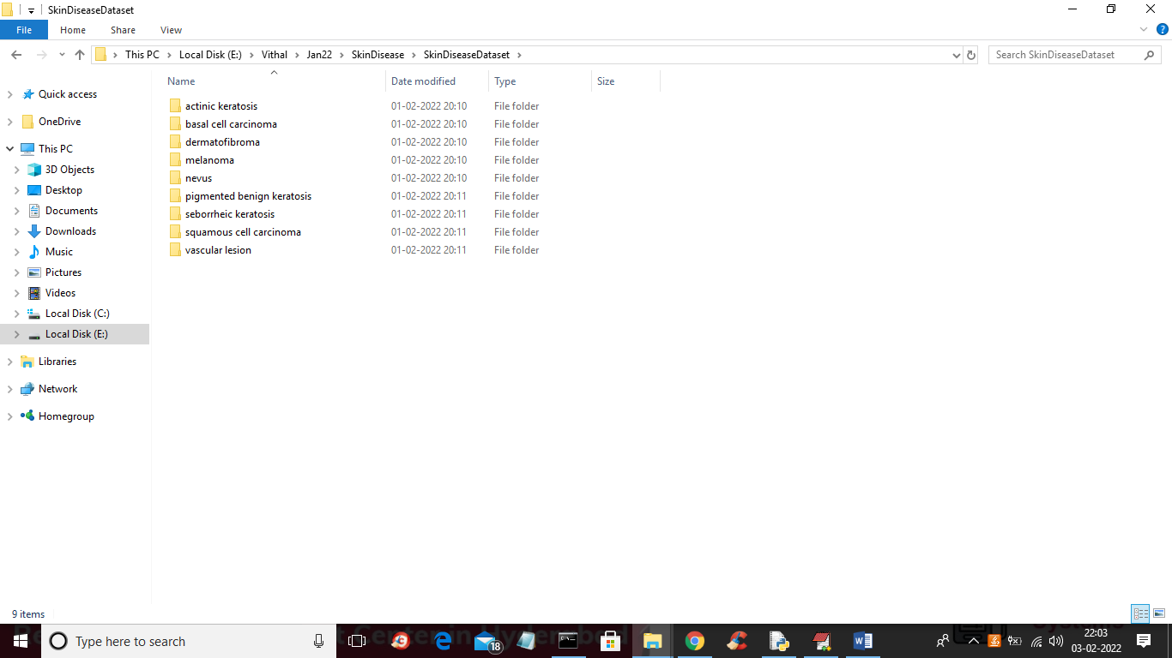

In above screen 9 different folders are there with different diseases names and just enter any folder to see that disease images. You can see below screen

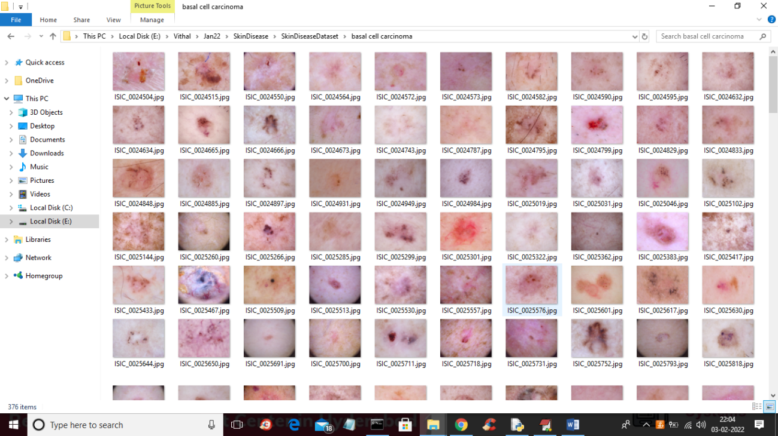

We are using above images to train CNN and below screen showing CNN code for training

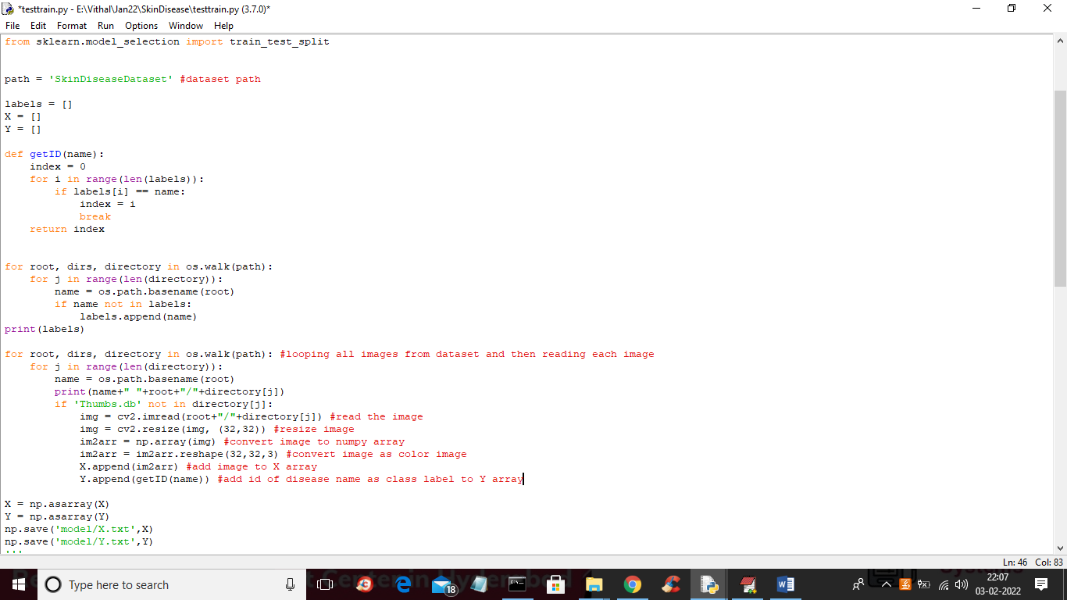

In above code read red colour comments to know about reading and processing images and then saving to X and Y array and in below screen we can CNN is getting training with X and Y array values

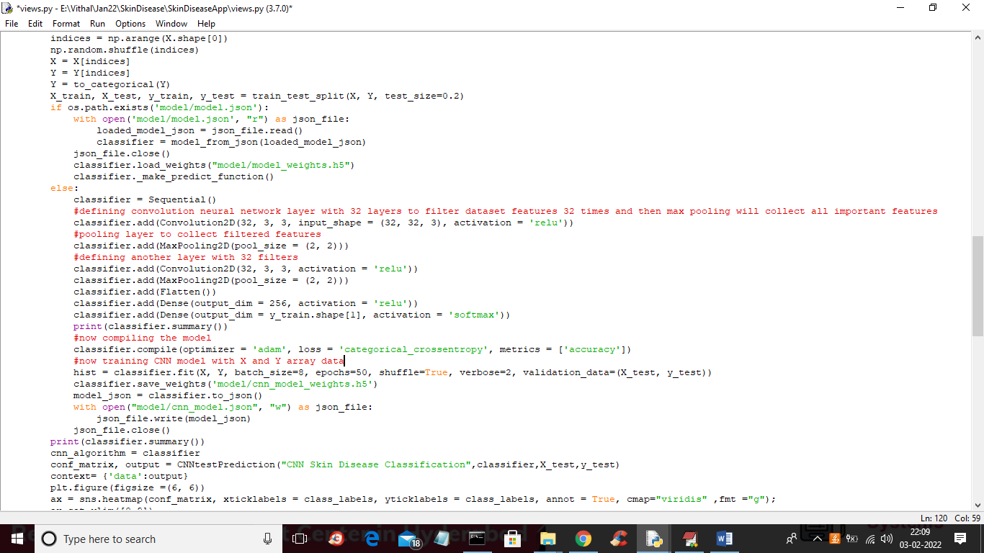

In above code you can see we are defining Convolution Neural Network (CNN) object and then training with X and Y array values.

**SCREENSHOTS**

To run project double click on ‘run.bat’ file to start DJANGO web server and to get below screen

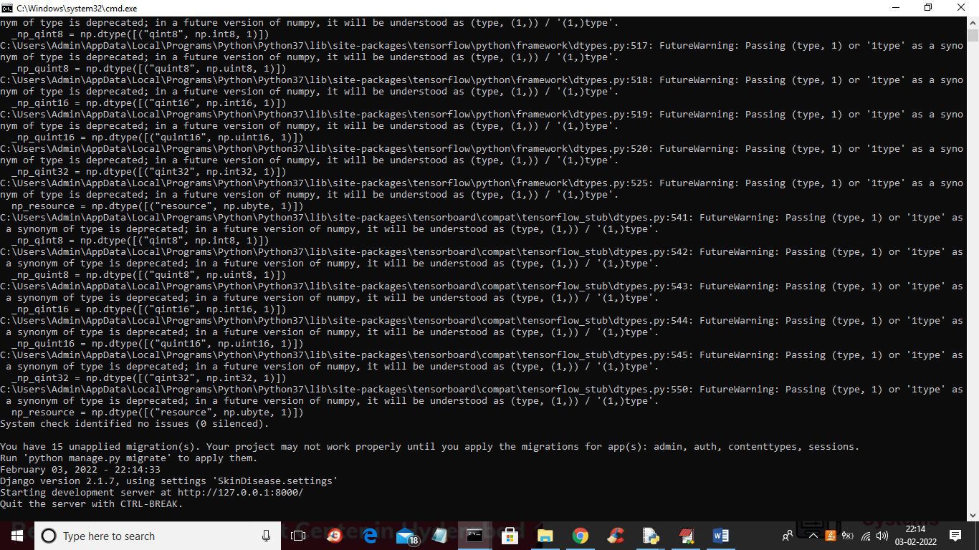

In above screen DJANGO server started and now open browser and enter URL as <http://127.0.0.1:8000/index.html> and press enter key to get below screen

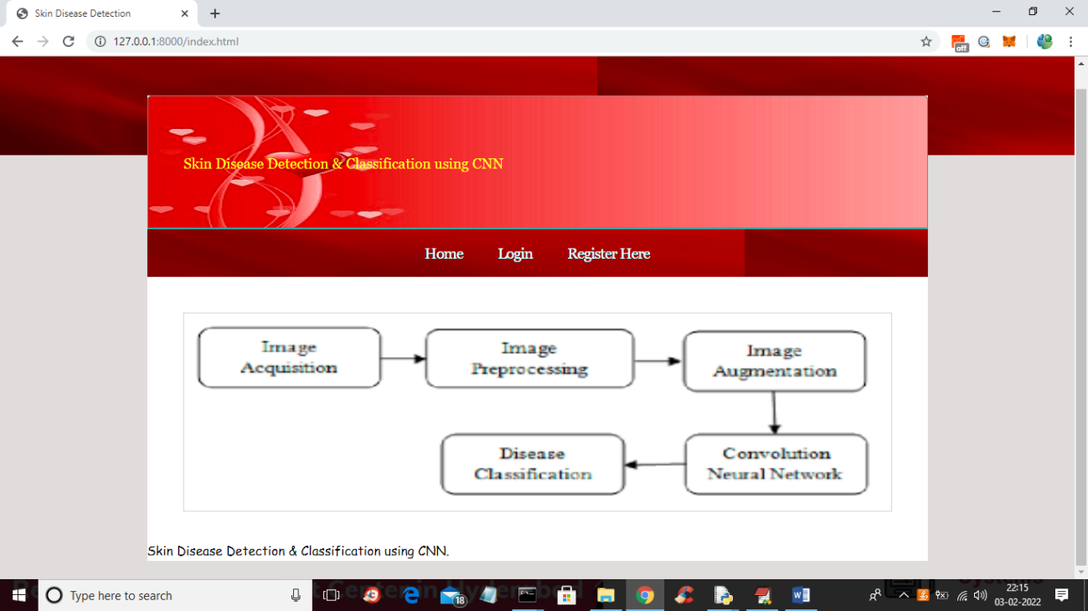

In above screen click on ‘Register Here’ link to get below signup screen

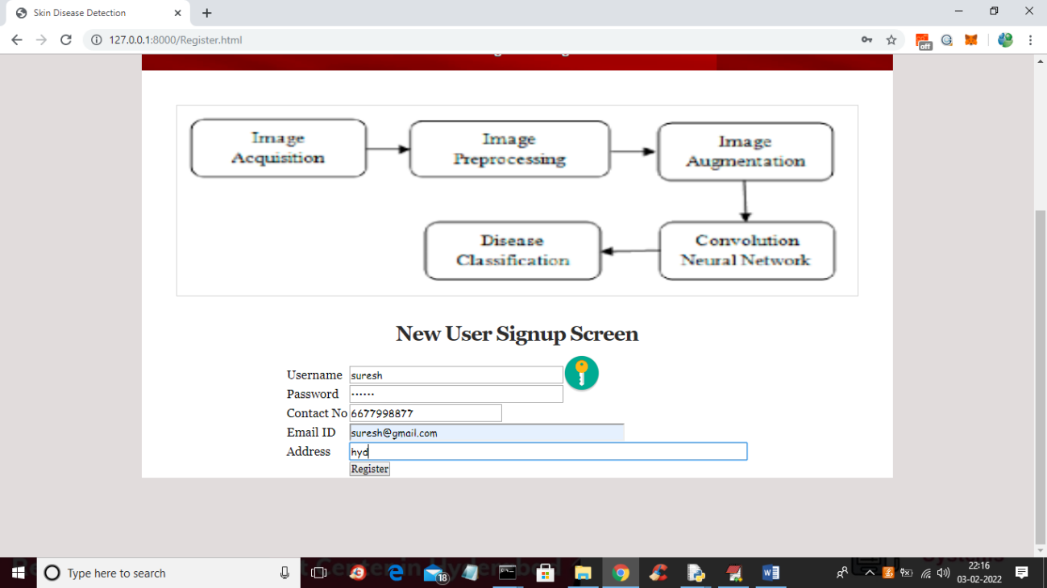

In above screen user is enter signup details and then press ‘Register’ button to complete signup process and to get below output

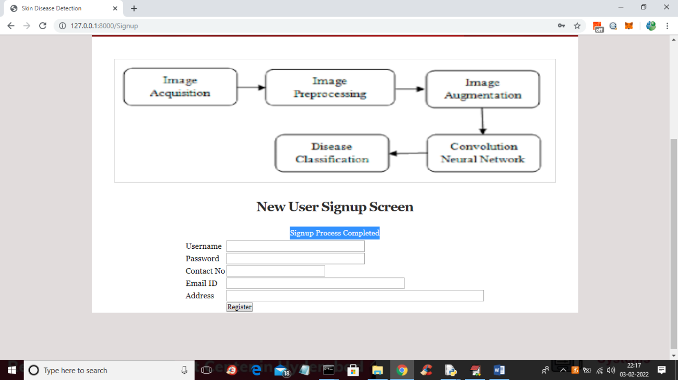

In above screen in blue colour text we can see signup process completed and now click on ‘Login’ link to get below screen

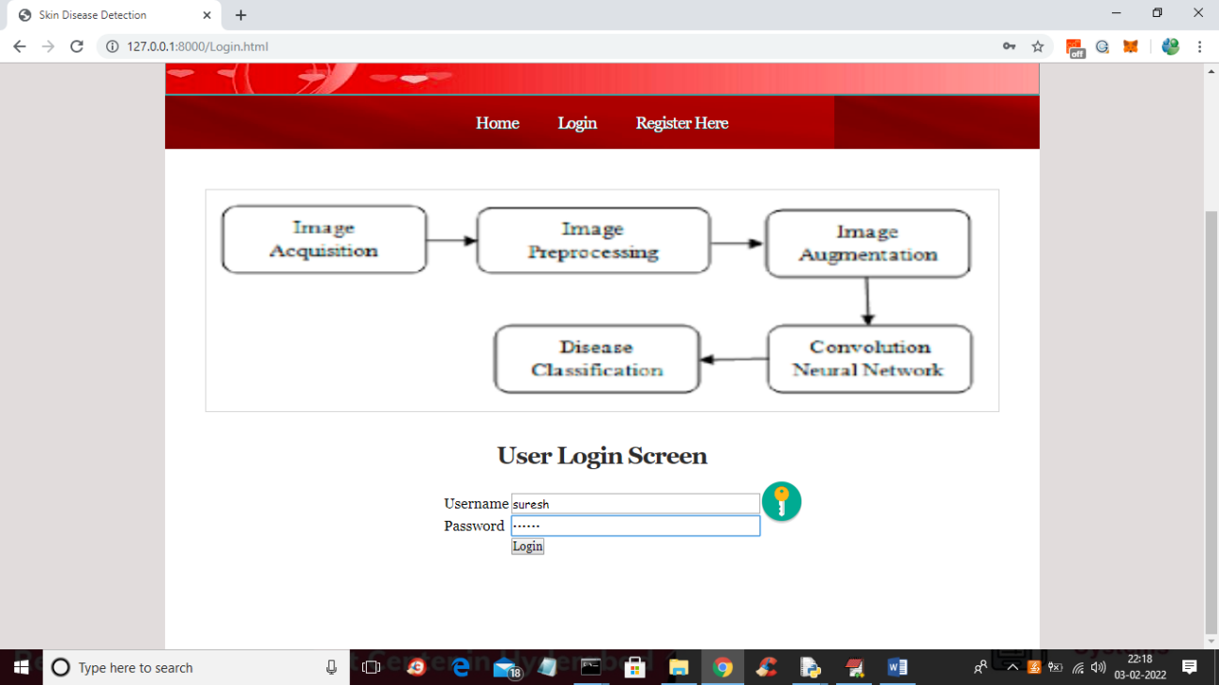

In above screen user is login and then click on ‘Login’ button to get below screen

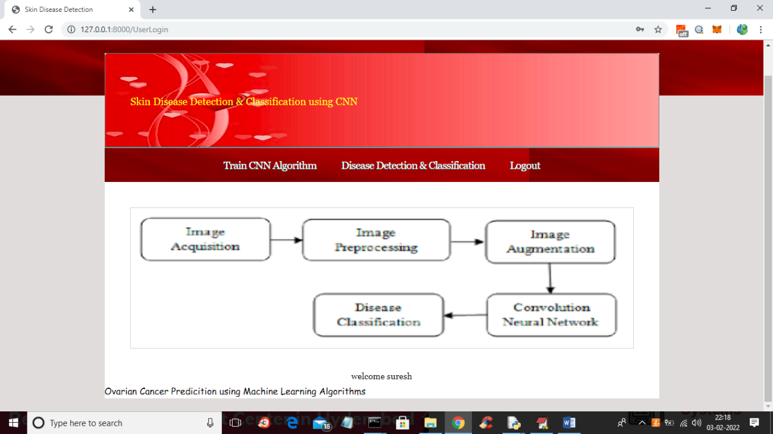

In above screen user can click on ‘Train CNN Algorithm’ link to train CNN and to get below output

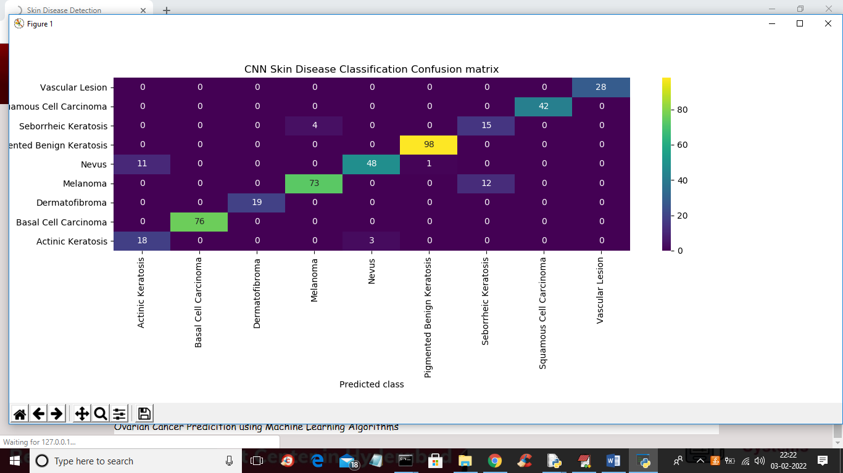

In above CNN confusion matrix graph we can prediction on test data and in above graph x-axis represents predicted disease names and y-axis represents original test classes and in above all values in diagnol boxes are the correct prediction and value > 0 which are not in diagnol are the wrong prediction and we can see only few records are wrongly predicted. Now close above graph to get below CNN accuracy

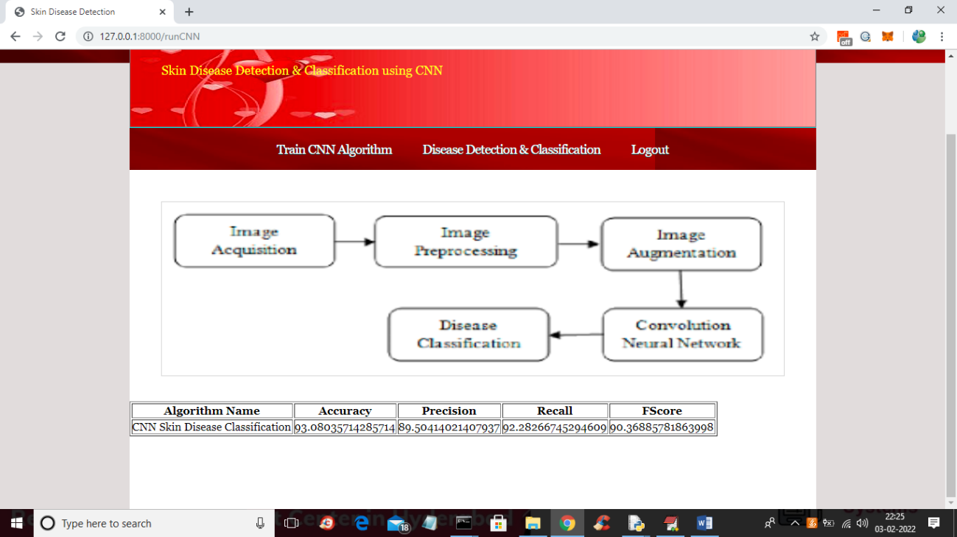

In above screen we got CNN accuracy as 93% and in below screen we can see CNN architecture

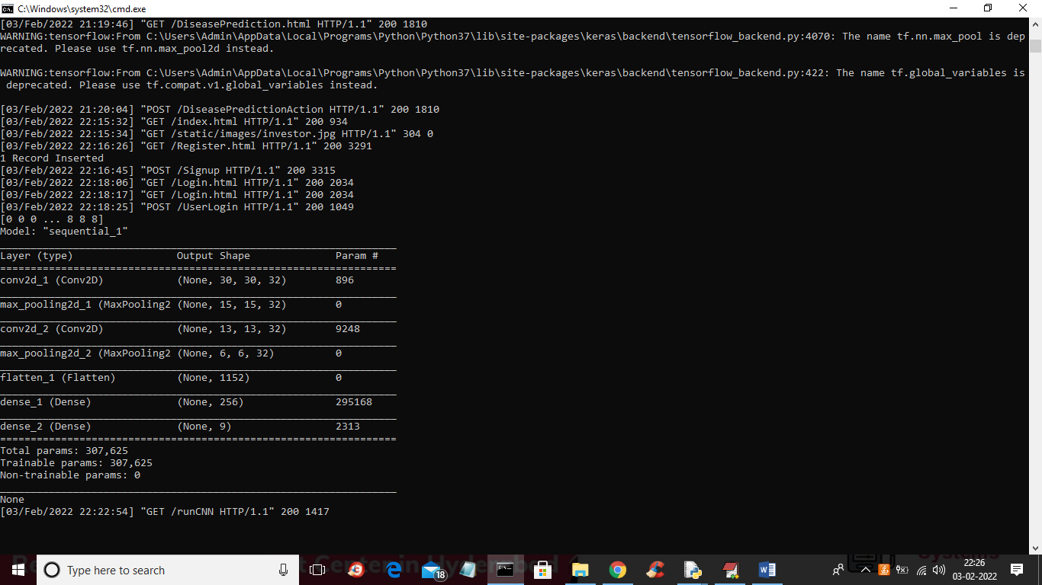

In above CNN architecture we have designed multiple layers with different image sizes such as 30 X 30, 15 X 15 etc. Now go back to output application and then click on ‘Disease Detection & Classification’ link to get below output

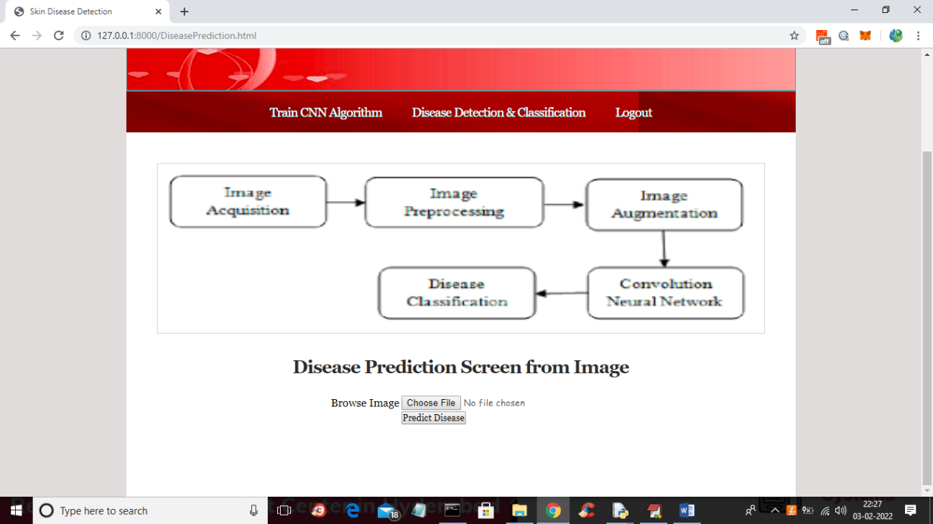

In above screen click on ‘Choose File’ button to upload skin diseases images from ‘testImages’ folder and then click on ‘Predict Disease’ button to classify disease

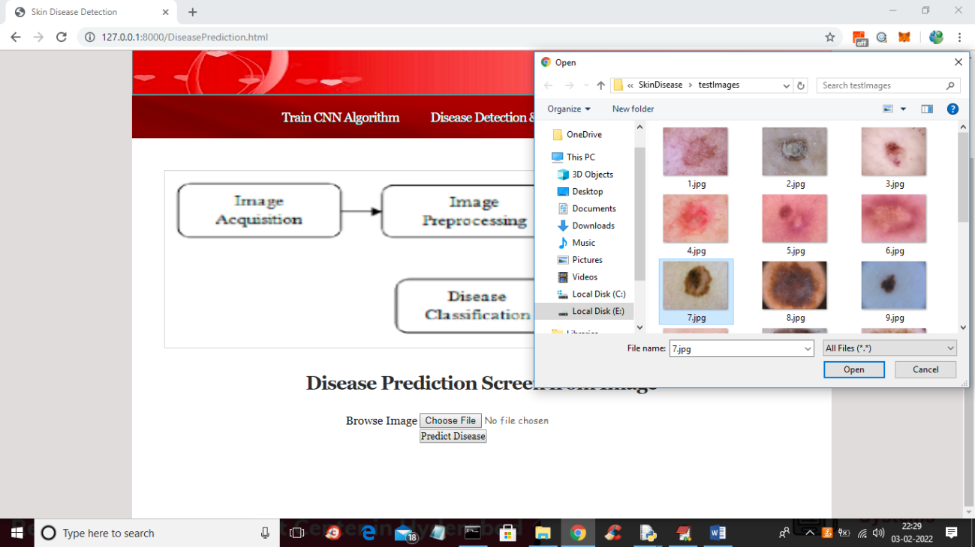

In above screen selecting and uploading ‘7.jpg’ and then click on ‘Open’ button to load image and then click on ‘Predict Disease’ button to get below output

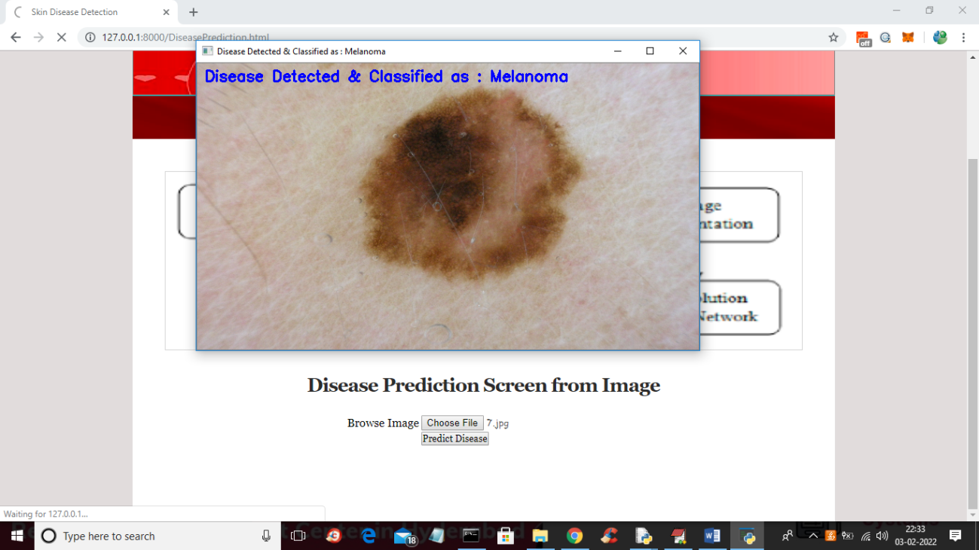

In above screen in blue color text we can see CNN classify disease on image as ‘Melanoma’ and similarly you can upload and test remaining images

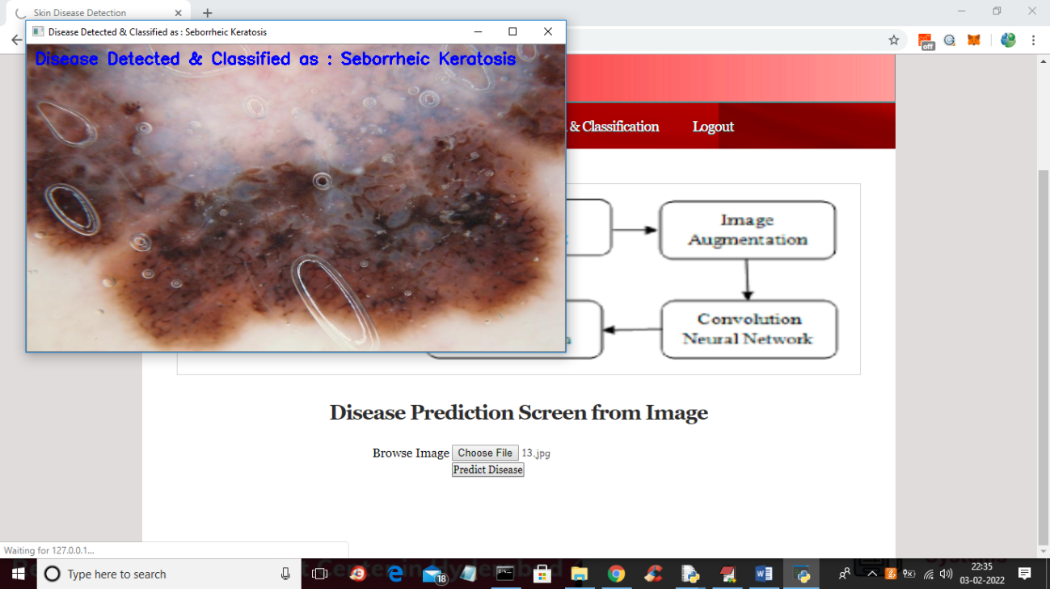

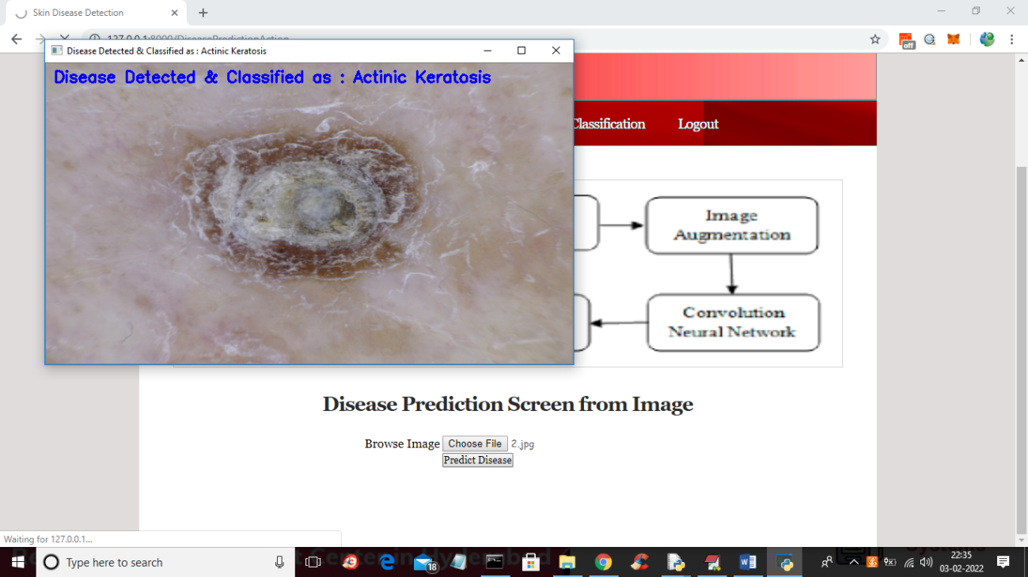

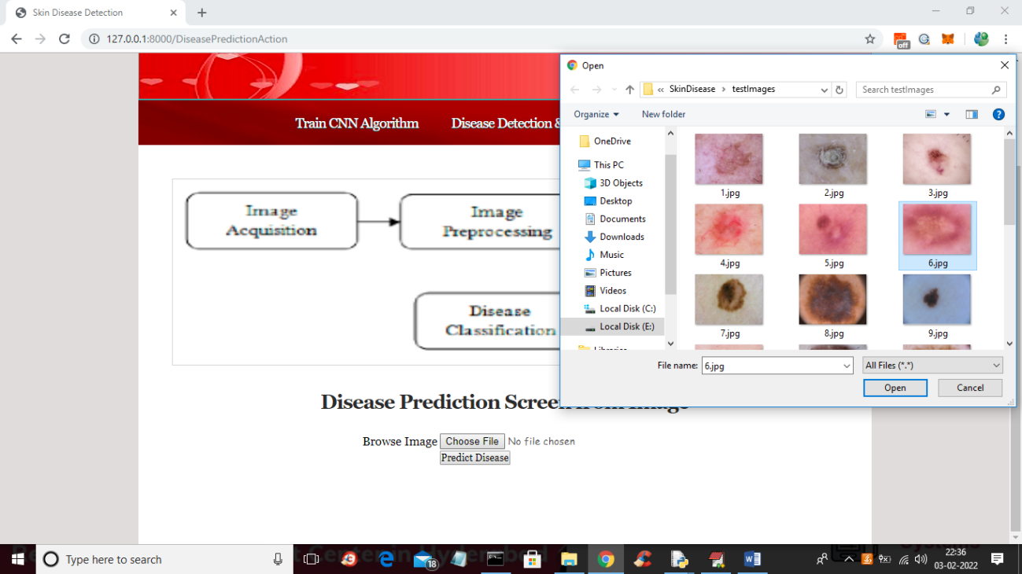

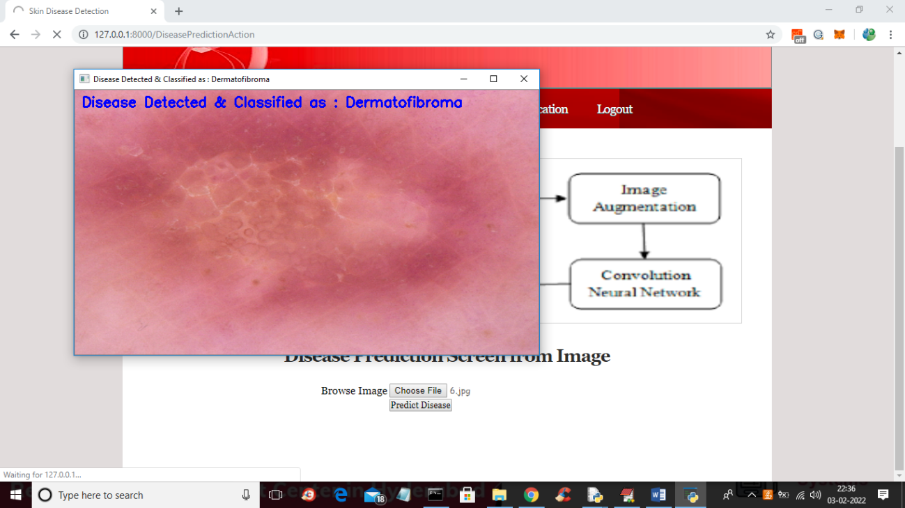

**RESULTS AND DISCUSSIONS**

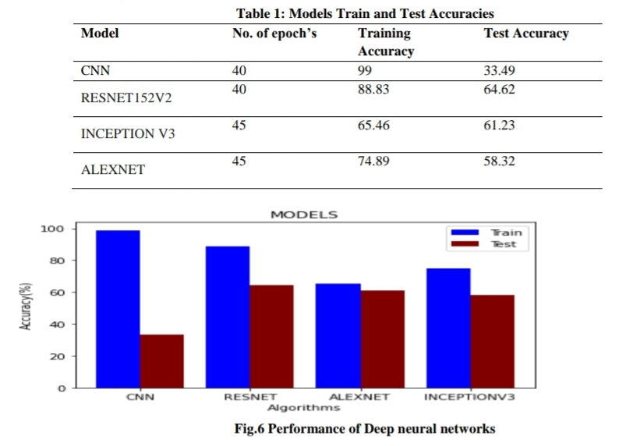The proposed system is to classify the given skin image as ‘Not a Skin disease” or one of the seven diseases namely Warts Molluscum, Systemic Disease, Seborrheic Keratosis, Nevus, Bullous, Actinic Keratosis, Acne and Rosacea using deep learning techniques. The dataset is divided into training and testing and deep learning models are build using CNN and three pretrained networks called Alex Net, ResNet, InceptionV3.The train and test accuracies of different models are shown in Table 1.

The train and test accuracies of CNN, Resnet, Alexnet and Inception-v3 are also shown in the bar graph (Fig.6).From the graph it is observed that CNN has outperformed over training Data but not on test data so it has lead to overfitting of the model. Resnet Train and test accuracies are better compared to the other models. So Resnet architecture can be used for detecting and prediction of skin diseases. Some of the results of our experiment are shown in Fig. 7.A new image can be given as input through our UI. The system detects whether it is skin disease or not. if disease classifies it into one of the seven diseases. highlights the effected portion of the skin and shows some tips as primary treatment.

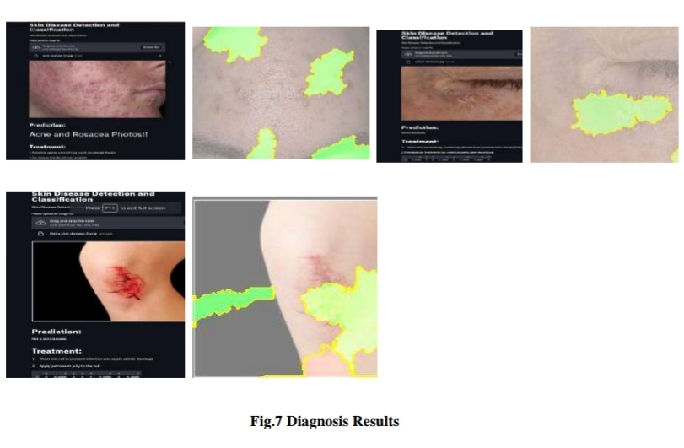

**CONCLUSION**

The feasibility of building a universal skin disease classification system has been investigated using CNN, Resnet, Alexnet and Inceptionv3. CNN has outperformed over training data but not on testing data. Better accuracy can be obtained by providing a training set with more variance and also by increasing its size. It is also found that Resnet has given better accuracy compared to other networks in the diagnosis of skin diseases

**REFERENCES**

[1] Sheng Ren, Deepak Kumar Jain, KehuaGuo, Tao Xu,Tao Chi. Towards Efficient Medical Lesion Image Super-Resolution based on Deep Residual Networks. Signal Processing: Image Communication75(2019):1-10.

[2] Article Classification of Skin Disease Using Deep Learning Neural Networks with MobileNet V2 and LSTM Parvathaneni Naga Srinivasu 1,† , Jalluri Gnana SivaSai 2 , Muhammad Fazal Ijaz 3,† , Akash Kumar Bhoi 4 , Wonjoon Kim 5,\* and James Jin Kang 6,\*

[3] Quan Gan,1 and Tao Ji1 , Skin Disease Recognition Method Based on Image Color and Texture Features, Computational and Mathematical Methods in Medicine / 2018 / Article, Volume 2018

[4] M. N. Alam, T. T. K. Munia, K. Tavakolian, F. Vasefi, N. MacKinnon and R. Fazel-Rezai, "Automatic detection and severity measurement of eczema using image processing," 2016 38th Annual International Conference of the IEEE Engineering in Medicine and Biology Society (EMBC),2016, pp. 1365-1368, doi: 10.1109/EMBC.2016.7590961.

[5] Parvathaneni Naga Srinivasu 1,† , Jalluri Gnana SivaSai 2 , Muhammad Fazal Ijaz 3,† , Akash Kumar Bhoi 4 , Wonjoon Kim 5,\* and James Jin Kang 6,\* Classification of Skin Disease Using Deep Learning Neural Networks with MobileNet V2 and LSTM, Sensors 2021, 21(8), 2852;

[6] Malliga, S. & Infanta, G. & Sindoora, S. & Yogarasi, S. (2020). Skin disease detection and classification using deep learning algorithms. International Journal of Advanced Science and Technology. 29. 255-260.

[7] N. Hameed, A. M. Shabut and M. A. Hossain, "Multi-Class Skin Diseases Classification Using Deep Convolutional Neural Network and Support Vector Machine," 2018 12th International Conference on Software, Knowledge, Information Management & Applications (SKIMA),2018, pp. 1-7, doi: 10.1109/SKIMA.2018.86315

[8] Haenssle HA, Fink C, Schneiderbauer R, et al. “Man against machine: diagnostic performance of a deep learning convolutional neural network for dermoscopic melanoma recognition in comparison to 58 dermatologists”. AnnOncol 2018;29:1836-42. 10.1093/annonc/mdy166

[9] A.Esteva, B. Kuprel, R. A. Novoa, J. Ko, S. M. Swetter, H. M. Blau,andS. Thrun, ‘‘Dermatologist-level classification of skin cancer with deep neural networks,’’ Nature, vol. 542,pp. 115–118, Feb. 2017.

[10] Alex Krizhevsky ,Ilya Sutskever, Geoffrey E,” ImageNet Classification with Deep Convolutional Neural Networks”. 1http://code.google.com/p/cuda-convnet.

[11] K. E. Purnama et al., "Disease Classification based on Dermoscopic Skin Images Using Convolutional Neural Network in Teledermatology System," 2019 International Conference on Computer Engineering, Network, and Intelligent Multimedia (CENIM), 2019, pp. 1-5, doi:10.1109/CENIM48368.2019.8973303.